# Homework #1: Testing Windows Server 2016 VM

|  |
| --- |
| * This is an individual assignment and is worth 20 points. * The due date is Wednesday, January 18th, 2:30 PM (sec01) / 5:30 (sec75). * Use the “CIS 483 HW#1-Tasks.docx” file to provide your outcomes. * Follow the naming convention: homework, underscore, last name, first initial, and extension (e.g., Homework #1_ImG.docx). For violation, I will deduct one point. * Do not use any of the sample screenshots provided as illustrations. * Zoom in the screenshots so that the images are clearly readable. When the images are not readable, I will deduct points. |

**(TASK #1: 5 points)** Login to the Windows Server and take a screenshot of the first screen.

* *This was the first screen that popped up from PROXMOX when I clicked on the SQL configuration manager. Hope this is correct!*
* 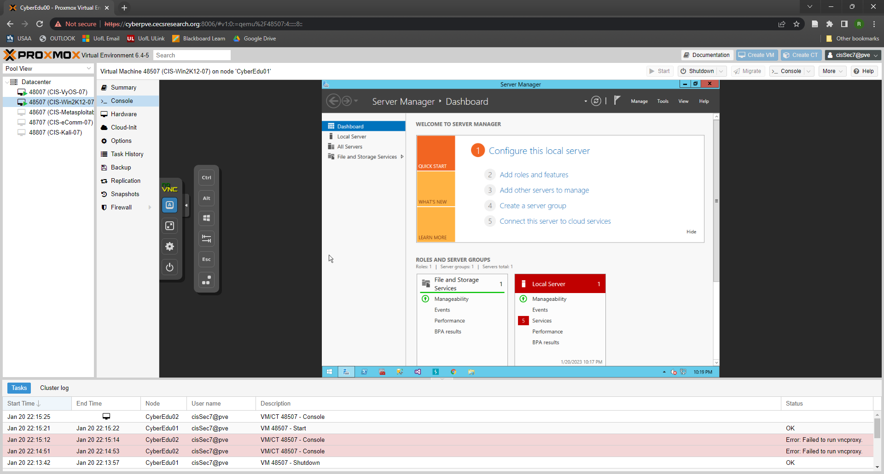

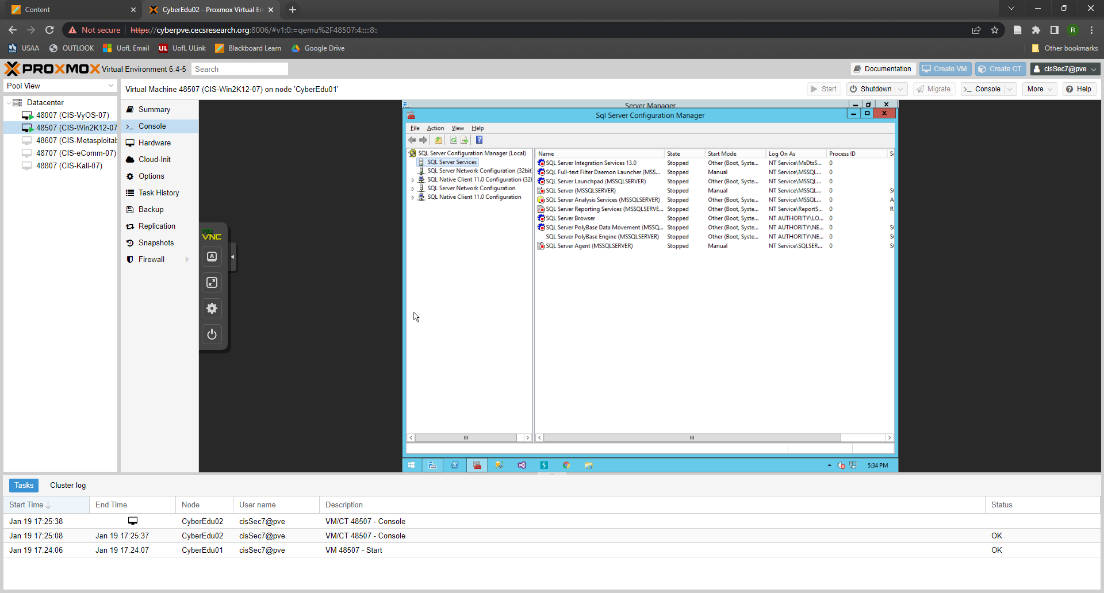

**(TASK #2: 5 points)** Show in a screenshot the services that are running.

**(TASK #3: 5 points)** Execute the following queries. Show the results in a screenshot. You must show that the installation is SQL Server 2016.

**(TASK #4: 5 points)** Execute the following query. Show the result in a screenshot. How many departments did you get with the query? I got 16 Departments

